Project Work 5

1.

1. Fine the player id given a player name. Turn in the results for Johnny Manziel.
   1. SELECT player_id FROM profiles WHERE name = “Johnny Manziel”
   2. db.profiles.find({name: “Johnny Manziel”}, {player_id: 1})
   3. 
2. For a given player_id, find the games in which that player appeared. Turn in results for id = 14013
   1. SELECT * FROM games WHERE player_id=*player_id*
   2. db.games.find({player_id: 14013}, {date: 1, game_number: 1, player_team_score:1, opponent_score: 1})
   3. Only displayed date, game number and the scores of the teams to remove clutter from the results
   4. 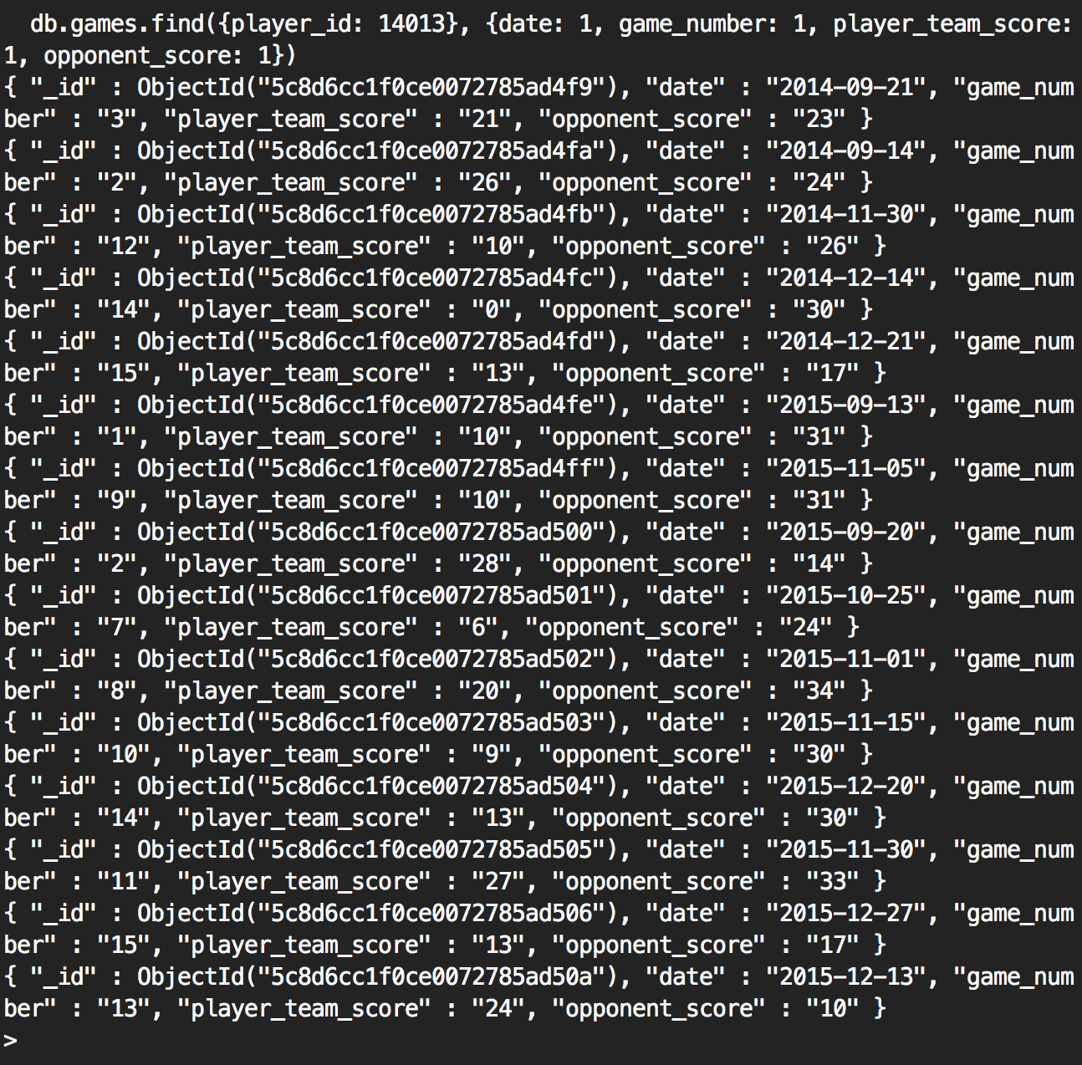
3. Use the Mongo aggregation pipeline to output the number of games played in by Tom Brady vs Terry Bradshaw
   1. SELECT * FROM (results for Tom Brady) UNION (results for Terry Bradshaw)
   2. Tom Brady player_id: 2240
   3. Terry Bradshaw player_id: 2230
   4. 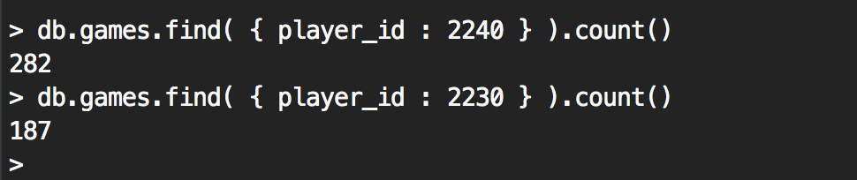
4. Use Map/reduce to print out the number of career TDs scored by Jim Brown vs Emmitt Smith
   1. SELECT sum(BrownTDs) FROM (SELECT rushing_touchdowns + receiving_touchdowns AS BrownTD FROM games WHERE player_ID=Jim_Brown_ID)
   2. Jim Brown
      1. db.games.aggregate([{$match:{player_id:2648}},{"$group" : {_id:"$player_id",BrownpTDs:{$sum:"$receiving_touchdowns" },BrownrTDs:{$sum:"$rushing_touchdowns" }}},{"$project" : {_id:"$player_id", BrownTDs:{$sum:["$BrownpTDs","$BrownrTDs"] }}}])
   3. 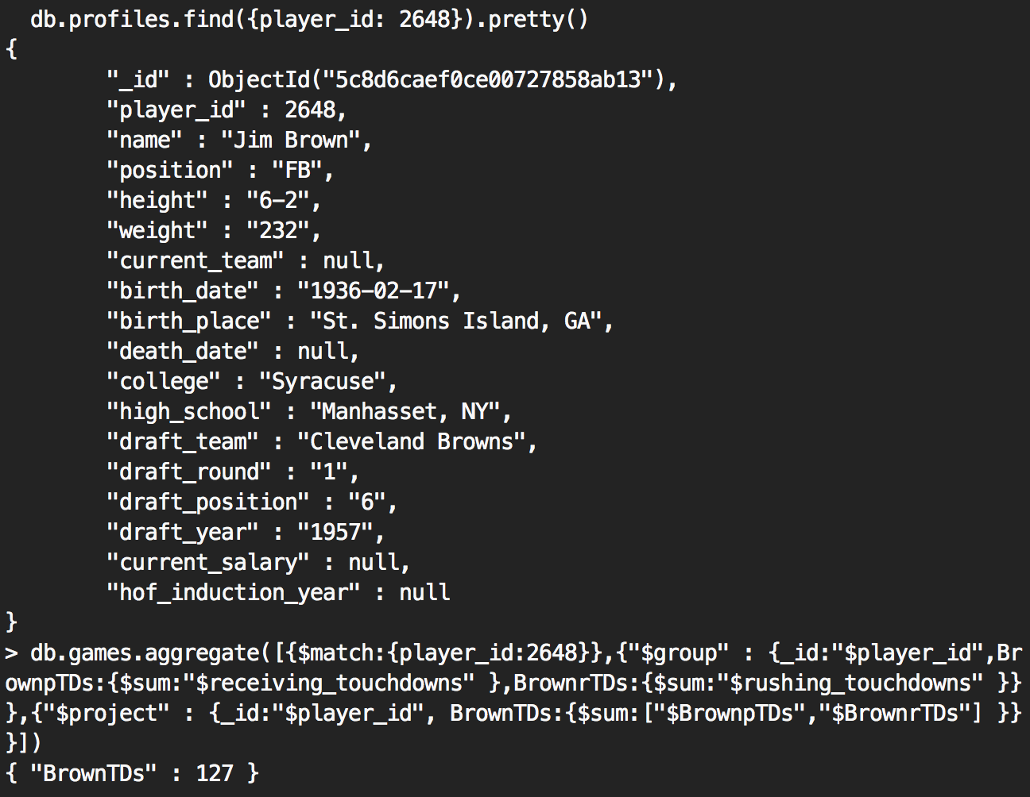
   4. Emmitt Smith
      1. db.games.aggregate([{$match:{player_id:2648}},{"$group" : {_id:"$player_id",BrownpTDs:{$sum:"$receiving_touchdowns" },BrownrTDs:{$sum:"$rushing_touchdowns" }}},{"$project" : {_id:"$player_id", BrownTDs:{$sum:["$BrownpTDs","$BrownrTDs"] }}}])
   5. 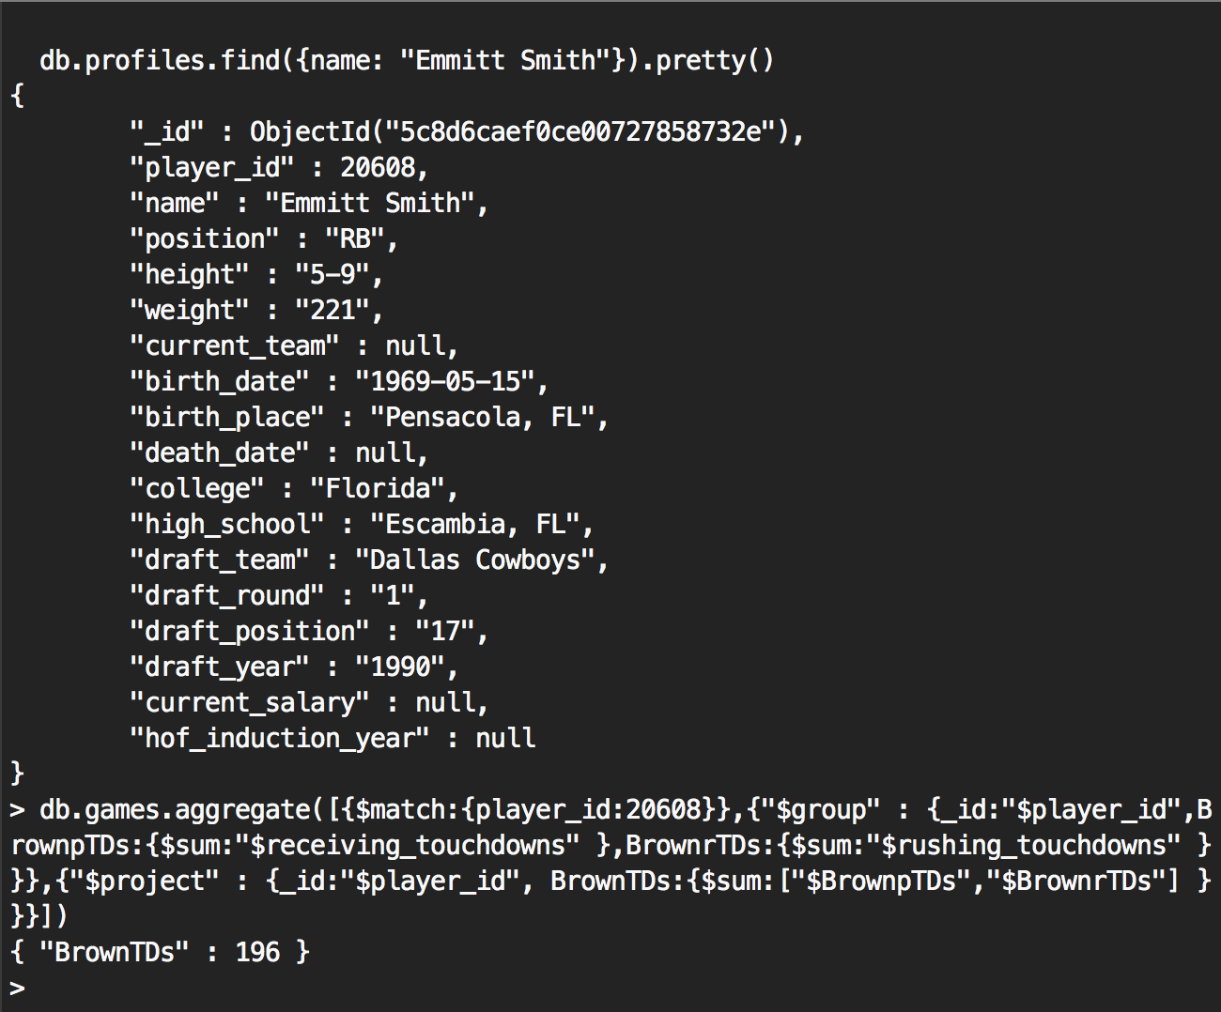

2.

1. For each year played, list a count of games in which John David Crow played.
   1. SELECT year, COUNT(*) FROM profiles NATURAL JOIN games WHERE name= “John David Crow” GROUP BY year;
2. In 1990, in what games and what Seattle players had interceptions in a game?
   1. SELECT games.game_number, profiles.player_id FROM games, profiles WHERE game.defense_interception <>0 AND games.team= “SEA” AND games.year= “1990” AND games.player_id = profiles.player_id;
   2. db.games.aggregate([{$match:{year:"1990", team: "SEA", defense_interceptions:{$ne:0}}},  {"$project":{_id:0, player:"$player_id", gameNum:"$game_number"}}])